**Mathematical modelling to inform policy decisions about a seasonal use-case for the RTS,S/AS01 malaria vaccine**

*Hayley A Thompson1, Matt Cairns2, Peter Winskill1, Alexandra B Hogan1, Azra C Ghani1*

*1MRC Centre for Global Infectious Disease Analysis, Imperial College London  
2Faculty of Epidemiology and Population Health, LSHTM*

**Summary**

* Population-level modelling indicates that in settings with seasonal malaria transmission seasonally targeted RTS,S vaccination (SV) results in greater absolute reductions in malaria cases and deaths over 15 years compared to RTS,S delivery though an aged-based Expanded Programme on Immunization (EPI) schedule.
* While SV may avert more cases than EPI, further exploration of SV clinical trial data and model results highlights that SV will result in delayed age at first vaccination depending on birth month, with the potential for this to leave some children at risk of malaria in their first transmission season.
* Reductions in malaria morbidity and mortality are greatest when vaccines are delivered in combination with Seasonal Malaria Chemoprevention (SMC), with SV + SMC predicted to result in the largest burden reductions when compared with either intervention implemented independently.
* In seasonal settings with medium to high transmission intensity and the absence of SMC, cost-effectiveness analysis, while illustrative, suggests that RTS,S vaccination is cost-effective at a cost per dose of $5. In the same seasonal transmission settings when SMC is already in use, RTS,S is not as cost-effective because benefits and costs are incremental to SMC. When RTS,S is used as a complement to SMC, ICERs are higher but of a similar magnitude as those reported elsewhere for EPI RTS,S delivery in perennial settings.
* When considering RTS,S vaccination in seasonal settings the potential achievable coverage will likely determine the most beneficial delivery approach locally. In addition, a Hybrid vaccination strategy (EPI priming with seasonal fourth and fifth doses) could potentially combine the advantages of EPI (maintaining young age at first vaccination) and SV (fourth and fifth dose efficacy maximised to peak risk) along with distributional benefits. However further modelling is needed to understand the implications of such a schedule.

**Background**

The RTS,S/AS01 vaccine for *P. falciparum* malaria is being considered for future introduction into the EPI childhood vaccination schedule in malaria-endemic regions with perennial transmission. In addition, there is potential for this vaccine to be used, either in combination with or separately to Seasonal Malaria Chemoprevention (SMC), in regions where malaria transmission fluctuates seasonally. The seasonal malaria vaccination Phase 3b clinical trial assessed the relative impact of these interventions in two locations in Mali and Burkina Faso. In this report, we use data from the trial and an individual-based transmission model of *P. falciparum* malaria transmission, to estimate the impact of a seasonal use-case of the RTS,S vaccine. We consider the population level reductions in clinical malaria cases and deaths over 15 years and the cost-effectiveness of several RTS,S strategies in the absence of SMC and incremental to SMC.

**Methods**

Model estimates of seasonal intervention impact were validated against the results of the seasonal malaria vaccination Phase 3b clinical trial by capturing the site-specific epidemiology at the administrative-1 level, and implementing the intervention delivery schedules, coverage, and age cohorts as reported in the trial. With several biologically-motivated assumptions about the levels and decay of RTS,S and SMC efficacy over time, model outputs aligned closely with trial results (Annex 1.1). Without the present capacity for re-fitting, multiple intervention models are presented here to represent our uncertainty in intervention effects (Annex 1).

The transmission model was parameterised as set out in Annex 2. Model comparisons were made across two seasonality archetypes, characteristic of the seasonality patterns across the Sahel (highly seasonal) and Sub-Sahel (seasonal) region (Figure A5) with a baseline *PfPR2-10* between 3-65%, vector control interventions are assumed to remain static over follow up and are therefore reflected in the baseline *PfPR2-10*. Moderate levels of access to care were assumed (Effective coverage (ie, treatment with parasitological cure) for clinical malaria of 45%).Three potential vaccination strategies were considered: EPI (age-based primary series and age-based fourth dose), SV (seasonally targeted primary series and seasonal fourth and fifth doses), and a Hybrid strategy (age-based primary series and seasonal fourth and fifth doses) (Table A2). The model structure cannot currently capture Hybrid vaccination strategies, therefore a simplified model of these schedules is presented in Annex 2.1, with the main results showing only EPI and SV deployment. Further population-level modelling of a Hybrid strategy is underway. Note that EPI is used as a shorthand descriptor of an age-based strategy (i.e. delivery of the first three doses between 5 and 9 months of age) and is not meant to imply a different role for immunization programs in delivering RTS,S vaccine seasonally.

**RTS,S impact – SV compared to EPI**

The model simulations showed that SV resulted in greater reductions in cases and deaths than EPI vaccination across all endemicity settings in both seasonal and highly seasonal settings over 15 years. An additional fifth dose and/or higher fourth and fifth dose efficacy against infection increased this impact (Figure 1).

Considering the effect of seasonality and in the absence of SMC, the incremental benefit of SV over EPI (defined as the proportion of additional events averted with an SV versus EPI schedule) was larger in highly seasonal settings compared to seasonal settings (average 75% additional cases and 64% additional deaths averted vs 60% additional cases and 55% additional deaths averted). This is likely a result of the burden of malaria being concentrated in a shorter time period in highly seasonal settings compared to in seasonal settings where burden is more uniformly spread over 5–6 months. The benefit of seasonally targeting vaccines was reduced when considering the impact per 100,000 fully vaccinated children due to the increased number of doses delivered in the SV schedule (Figure 1B, 1D).

Despite SV resulting in the largest reductions in malaria cases and deaths over the 15-year period, modelling results showed EPI be more beneficial than SV during 10–20 months of age (when children are at higher risk of severe malaria outcomes), due to the disparity in ages of the first vaccine dose between strategies (Annex 2.1). A Hybrid strategy that uses EPI delivery for the primary series could potentially be more impactful than SV by preserving a young age at first vaccination and retaining the population level benefits of seasonally targeted fourth and fifth doses that result in greater aggregate reductions in morbidity and mortality at older ages (Annex 2.1).

**Figure 1** Cumulative clinical cases averted over 15 years as a function of baseline PfPR2-10 (four settings representative of medium to high transmission intensity are shown) and seasonality **A&C**) per population and **B&D**) per 100,000 fully vaccinated children. Coverage is fixed at 80% for the first three doses with a 20% drop off (from the 3rd dose) for the fourth and fifth doses (coverage is the same for the 4th and 5th dose). Fully vaccinated children are defined as those receiving the primary series (first three doses). EPI- is the four-dose age-based strategy, SV 4&5-dose is the seasonal strategy assuming the original vaccine efficacy profile from the Phase 3 RTS,S trials, SV 4&5-dose – updated booster is the seasonal strategy assuming the updated higher efficacy against infection for the 4th and 5th dose based on our validation to the seasonal malaria vaccination Phase 3b clinical trial (Annex 1).

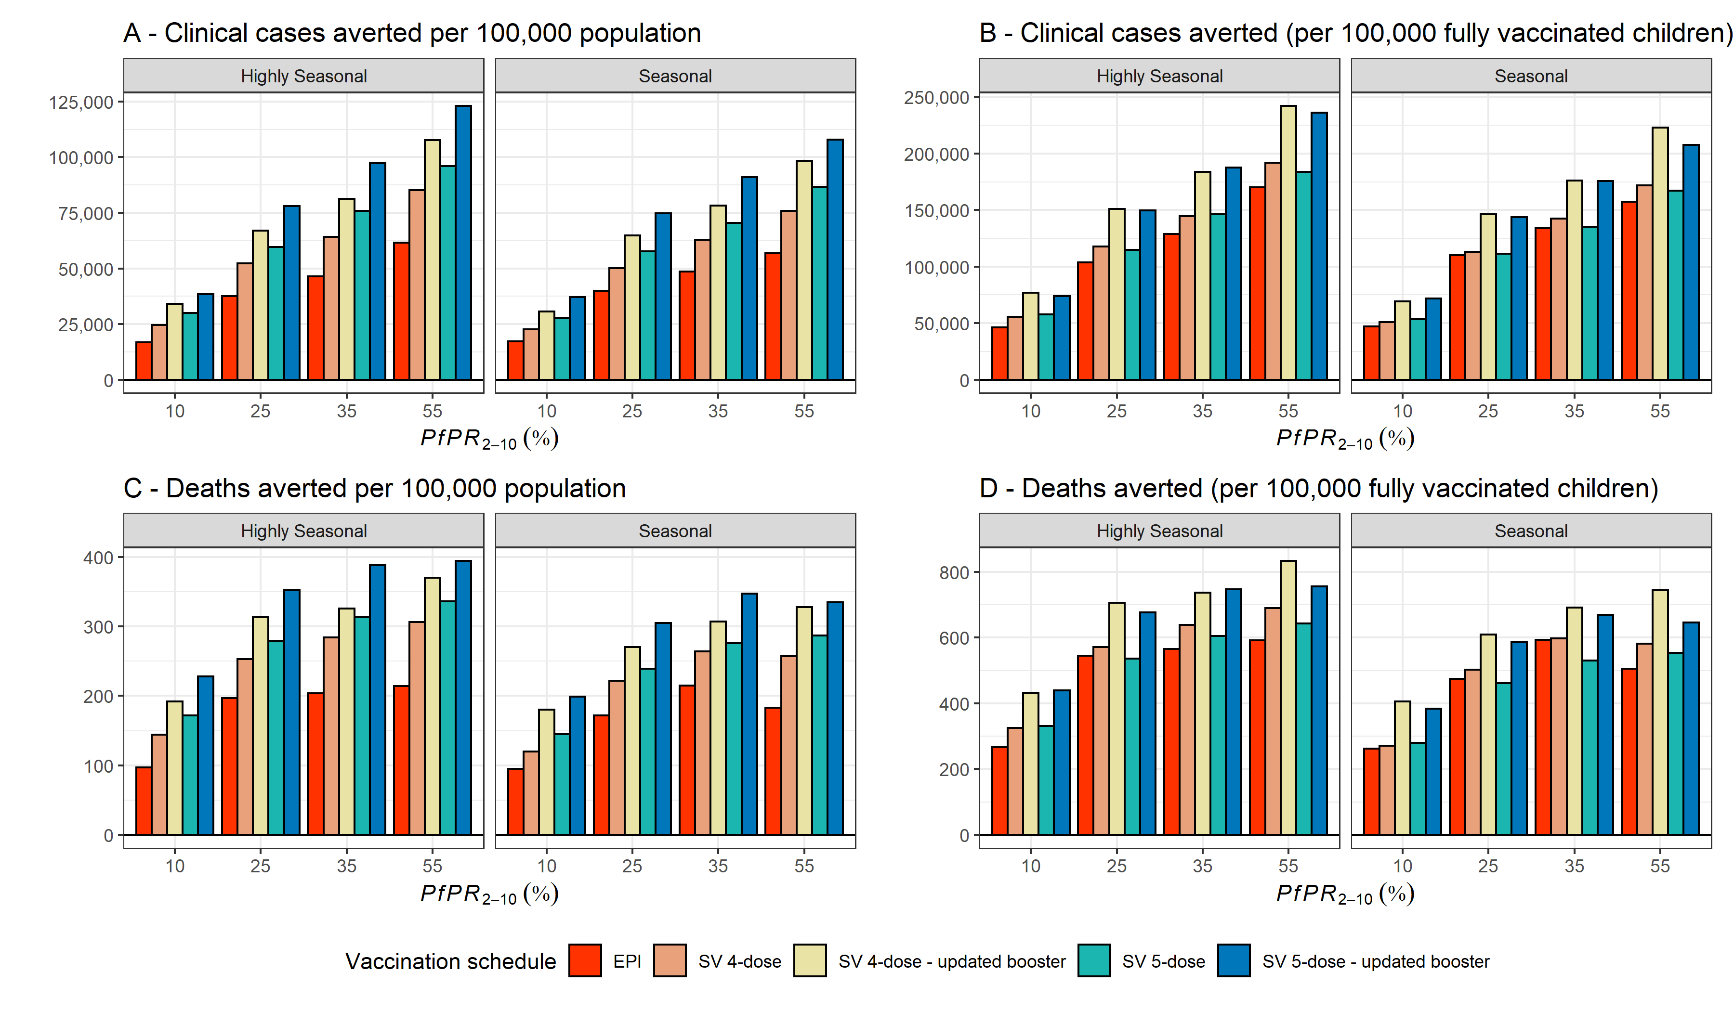

**RTS,S impact with SMC delivery**

The model simulations indicated the combination of RTS,S and SMC to be substantially more impactful than either intervention alone in seasonal settings. The combination of SV + SMC resulted in a greater number of cases and deaths averted compared to EPI + SMC (Figure 2). The inclusion of SMC alongside a vaccination schedule also reduces the effect of disparity in age at first vaccination between SV and EPI (Figure A11).

On average across both seasonality profiles and endemicity levels, SV + SMC averted an additional 61% more cases than SMC alone with EPI + SMC averting an additional 31% more cases than SMC alone. When interventions were combined, the additional impact of vaccination over SMC was higher in seasonal settings , where the burden is spread over more of the year, than in highly seasonal settings. This may reflect the greater importance of protection from RTS,S outside the peak transmission season, in areas where transmission is less seasonal, when SMC is in place to address the burden during the peak months.

**Figure 2** Cumulative clinical cases and deaths averted over 15 years per population as a function of baseline PfPR2-10 (four representative of medium to high transmission intensity are shown)and seasonality. Coverage is fixed at 80% for the first three doses with a 20% drop off for the fourth and fifth doses. SMC coverage at 75%. EPI- is the four-dose age-based strategy, SV 4&5-dose is the seasonal strategy assuming the original vaccine efficacy profile for the Phase 3 RTS,S trials. SV 4&5-dose – updated booster is the seasonal strategy assuming the updated higher efficacy against infection for the 4th and 5th dose and synergy the increase in the modelled total RTS,S and SMC efficacy against infection above that of each intervention when they are considered alone based on the seasonal malaria vaccination Phase 3b clinical trial.

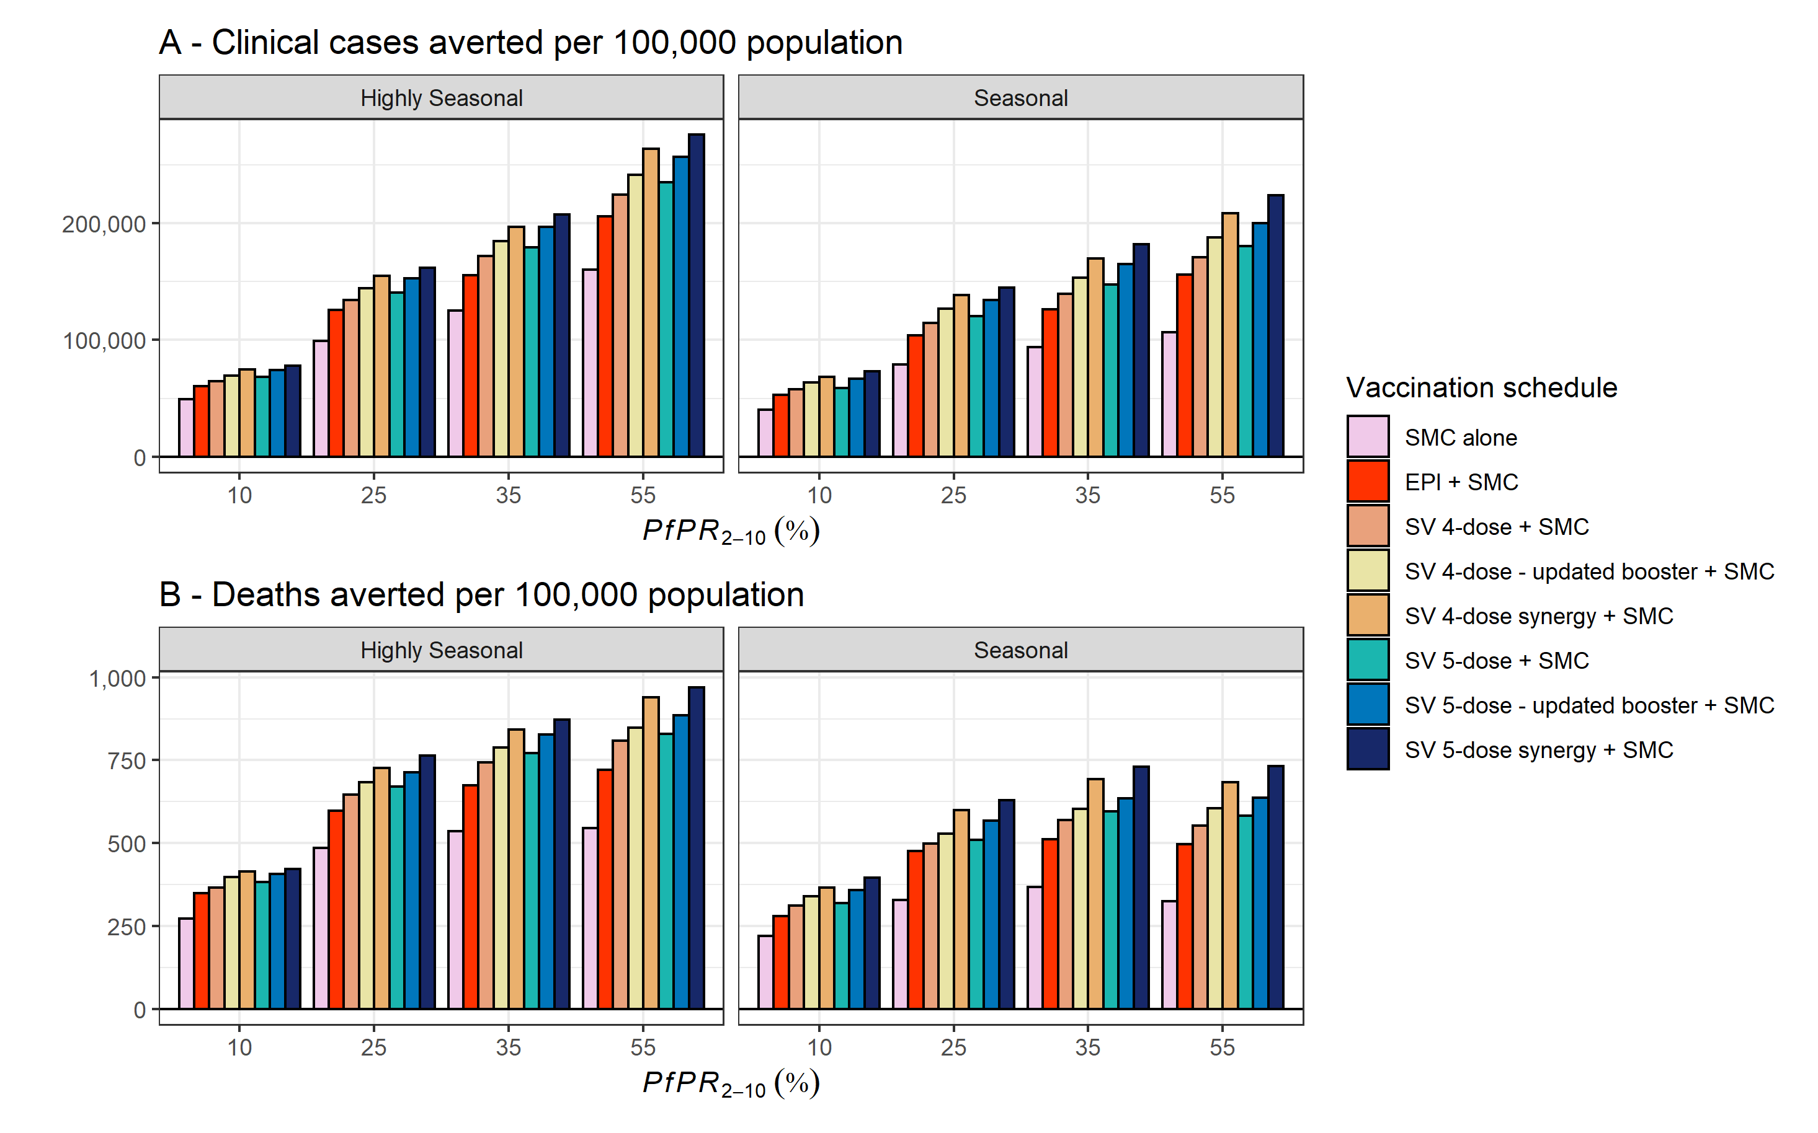

**Cost-effectiveness**

As no seasonal delivery cost data or introduction data is yet available for RTS,S, costs were assumed to be equivalent to EPI vaccination costs informed by MVIP data (Annex 3).

When compared with no-vaccination, no SMC and standard levels of access to treatment and existing vector control at an assumed cost per dose of $5, ICERs for RTS,S vaccination alone in seasonal settings were generally around $100 per DALY averted and less than $35 per case averted for a *PfPR2-10* between 10%-50% for all vaccination schedules (Table 1, Figure A14). Incremental cost-per-case and cost-per-DALY averted for each vaccination schedule were lowest at intermediate to high levels of baseline *PfPR2-10.* Overall, the model estimated that ICERs were marginally lower for all SV schedules (i.e. more cost-effective) despite the higher number of overall doses delivered (Table 1, Table A5).

We also consider whether the addition of RTS,S to SMC is cost-effective relative to 4 monthly cycles SMC alone. The cost-per-additional-case and -DALY averted were lowest at intermediate to high levels of baseline PfPR*2-10*. Across transmission settings RTS,S combined with SMC was less cost-effective than when considering seasonal settings when SMC was not used. For an assumed cost per dose of $5, ICERs were generally lower than $160 per DALY averted and less than $50 per case averted for a *PfPR2-10* between 10%-50% (Table 1, Figure A15). Again, ICERs were lower for all SV schedules relative to EPI when combined with SMC (Table 1, Table A6). ICERs for SV and EPI schedules are higher but of a similar magnitude to those reported elsewhere for perennial settings.

**Table 1.** Comparison of cost-effectiveness estimates after 15 years of intervention delivery in regions with a *PfPR2-10* between 10-50%. Results are averaged across both seasonality profiles. Results presented for a mean vaccine delivery cost of $1.62 per dose and unit cost of SMC of $1.07 per monthly cycle.

|  |  |  |  |  |
| --- | --- | --- | --- | --- |
|  | **Interventions** | | | |
|  | EPI1 | SV1,3 | EPI + SMC2 | SV + SMC2,3 |
| ICER per DALY averted | | | | |
| $2 per dose | $58.04 | $47.63 | $81.58 | $60.09 |
| $5 per dose | $112.84 | $93.25 | $157.63 | $117.39 |
| $10 per dose | $204.28 | $169.36 | $284.59 | $212.98 |
| ICER per clinical case averted | | | | |
| $2 per dose | $17.66 | $14.04 | $26.30 | $18.18 |
| $5 per dose | $34.29 | $27.44 | $50.80 | $35.31 |
| $10 per dose | $62.03 | $49.80 | $91.67 | $64.01 |

1Incremental to no SMC and standard levels of access to treatment and existing vector control  
2Incremental to SMC delivery at 75% coverage and standard levels of access to treatment and existing vector control  
3Averaged across all SV intervention efficacy and dose models

## Annex 1 – Model validation results

**Annex 1.1 Seasonal intervention model changes**

The seasonal malaria vaccination Phase 3b clinical trial occurred in two locations in southern Burkina Faso and Mali over the years 2017–2020. There were three trial arms: SV alone; SMC alone; and SV and SMC combined. We used the Imperial College London malaria transmission model to simulate the trial, by capturing the site-specific epidemiology at the administrative-1 level, and implementing the intervention delivery schedules, coverage, and age cohorts as reported in the trial.

**Figure A1 Model validation results.** The datapoints in black are the trial reported pairwise Hazard Ratios for the intervention comparisons (Intention-to-treat) listed on the x-axis and the coloured triangles the model predictions. Dashed horizontal line represents the trial specified non-inferiority margin at 1.2 for RTS,S compared to SMC alone and the solid line the equivalence limit at IRR = 1. Colours represent the validation steps and the intervention efficacy model changes implemented in Annex results and Figure A2. Initial model estimate refers to the baseline intervention efficacy models of RTS,S and SMC from previous fittings. Original booster represents the RTS,S fourth dose efficacy profile fitted from the Phase III trial data. Updated booster represents increasing the efficacy of the fourth and fifth dose to the same level as after the primary series. Combined arm update represents an increase in the modelled RTS,S and SMC efficacy above that of each intervention when they are considered alone.

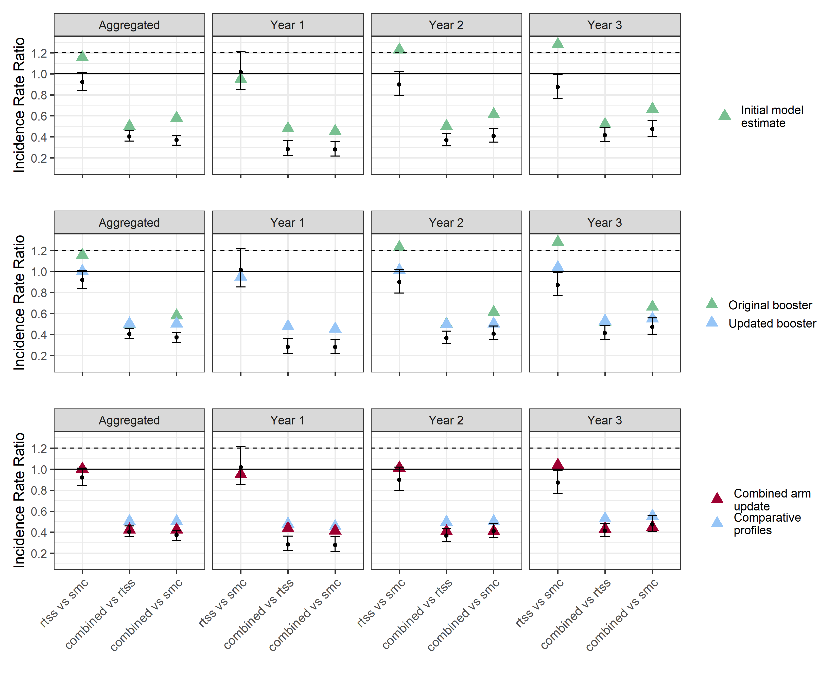

Preliminary model validation revealed several inconsistencies between the trial and model results. Figure A1row 1compares model estimated Incidence Rate Ratios (IRRs) aggregated over both countries at four different time points to those reported in the trial. While the model estimated IRR between SV and SMC fell within the 95% Confidence Interval of the trial results for Year 1, the model underestimated the remaining IRRs across all comparison arms and time points. We explored several variations to model parameterisation to investigate these differences.

Firstly, the RTS,S efficacy profile implemented in these simulations assumes that efficacy following the fourth dose does not reach the same levels as after the primary series [1] (Figure A2). However yearly trial results suggest that efficacy of additional doses is comparable with that of the primary series (Figure A1). This increased efficacy could potentially result from the reduction in time between doses from 18 to 12 months having an impact on immune responses or reduced parasite exposure between doses over the dry season. Therefore, a modified fourth and fifth dose efficacy model was considered in which fourth and fifth dose efficacy reaches the same level as after the primary series (Figure A2). The results from this updated efficacy profile fell within or on the edge of the 95% CI of the IRR between SV and SMC across all time points (Figure A1 row 2).

However, the model still underestimated the impact of the combined intervention arms when compared to each single intervention alone (Figure A1 row 2). This could be a result of synergies that occur when interventions are combined that are not currently captured in the model. For example, such synergies could potentially result from the vaccine induced reduction in the liver-to-blood inoculum of parasites resulting in more efficient clearance of parasites by SP+AQ. To test this, a third comparison was conducted where we employ the efficacy models shown in red in Figure A2 for the combined arm only. With these changes the model results for the combined arm comparisons were more closely aligned to the trial results falling within the 95% CI for the majority of time-points (Figure A1 row 3).

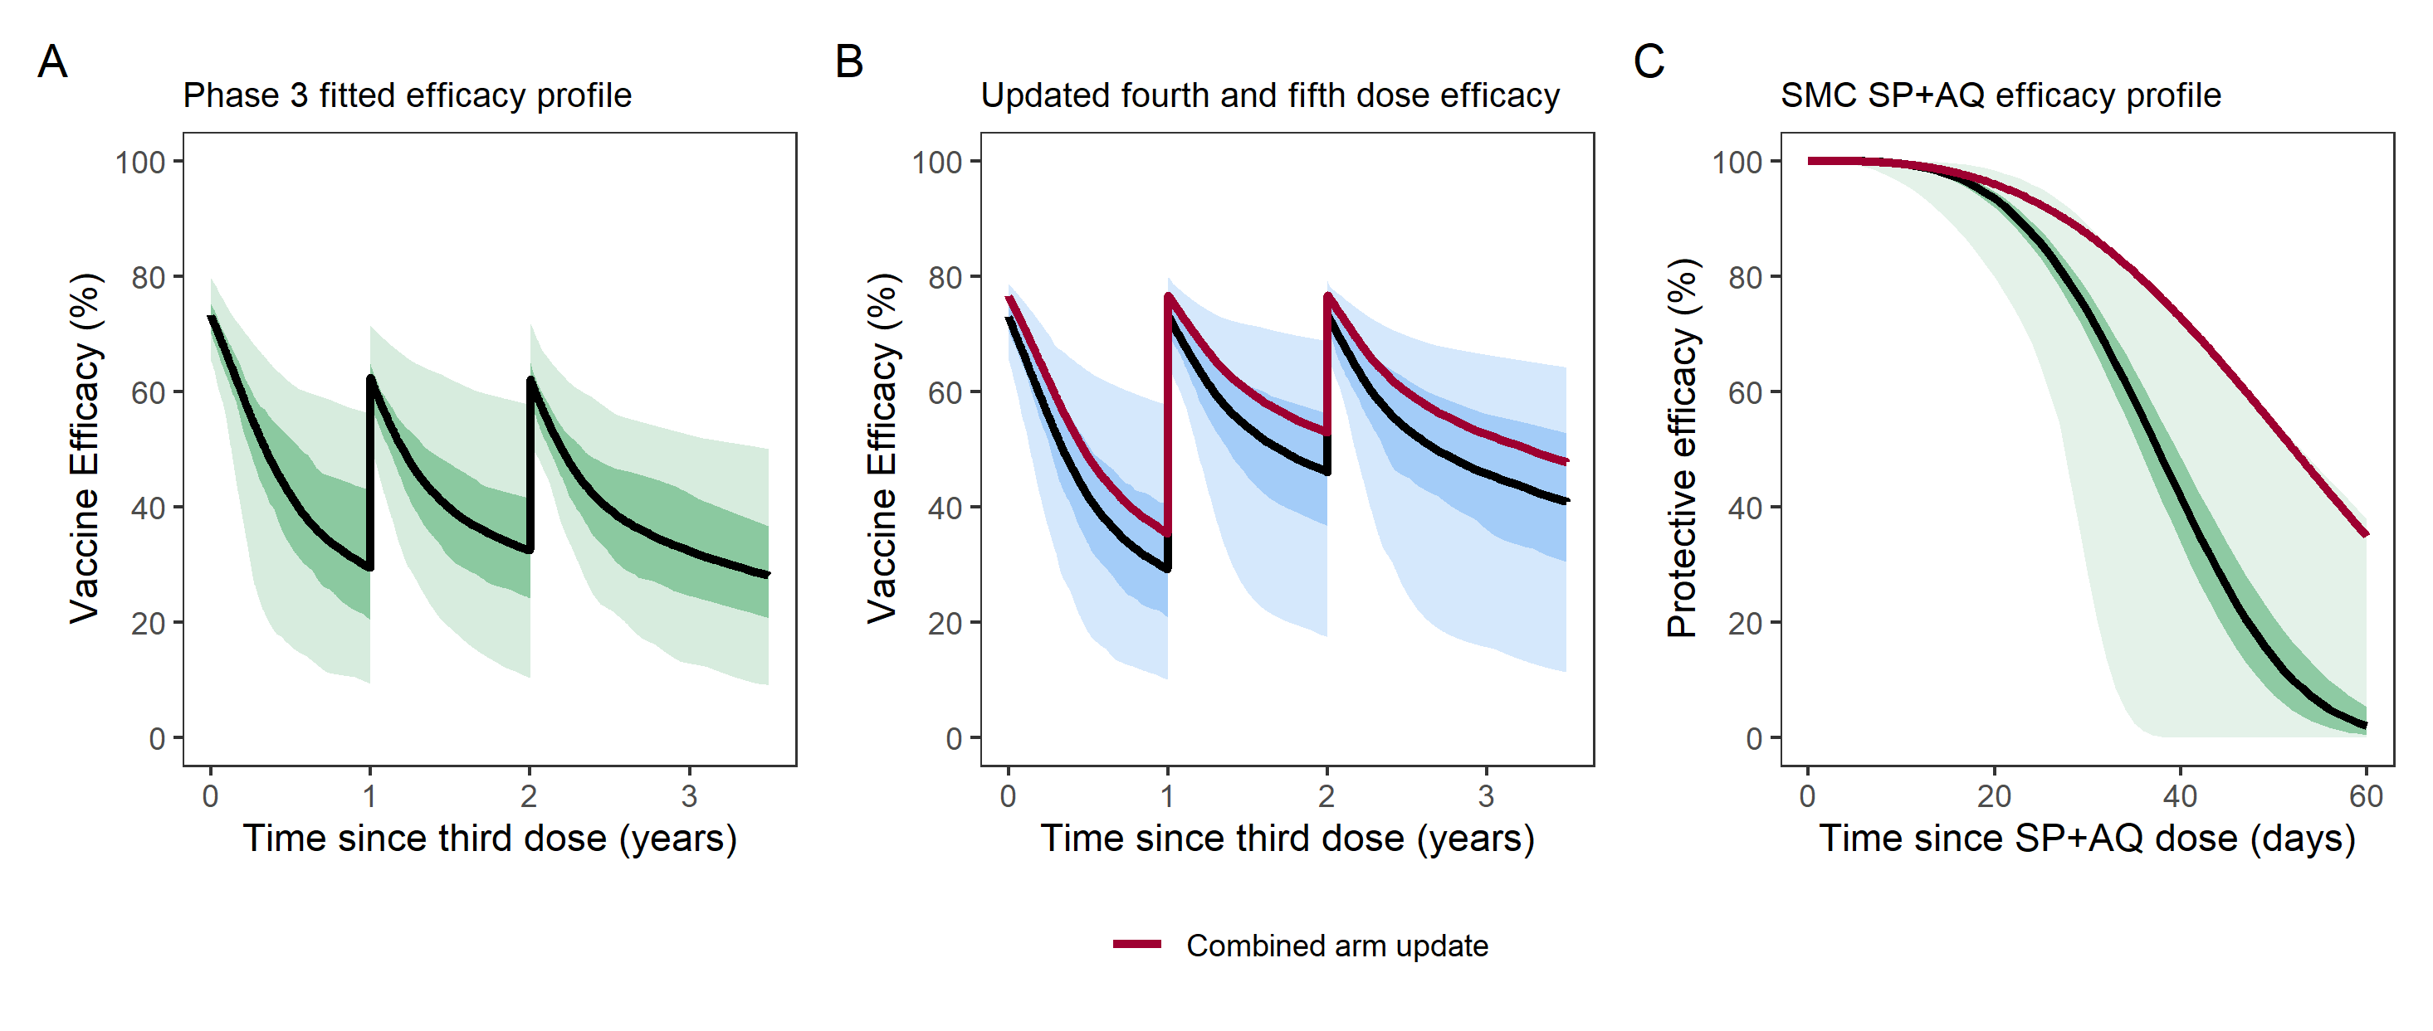

**Figure A2 Intervention efficacy models. A)** Efficacy profile for the seasonal vaccination schedule based on the parameters from fitting to Phase III trial data. **B)** UpdatedEfficacy profile for the seasonal vaccination schedule whereby the efficacy following the fourth and fifth doses returns to the same level as following the primary series but wanes at the rate described by the Phase III fitted model of the fourth dose. **C)** SP+AQ efficacy profile. The red line corresponds to the efficacy profiles selected for the combined arm synergy updates. Models were selected through sampling over the parameters draws that describe the uncertainty in our efficacy profile and selecting the parameters that brought validation results closest to those reported in the trial. Black lines in all three plots correspond to the median parameters that describe efficacy with the shaded areas the 50% and 90% Credible Intervals.

The trial finding of SV non-inferiority to SMC depends not only on the performance of the vaccine under seasonal conditions but also the performance of SMC. SMC programmes with four monthly cycles have been shown to be too short for the seasonality patterns in trial locations and five-monthly cycles are now the standard of care in Hounde, Burkina Faso. If five cycles of SMC had been delivered the modelling suggests that the results comparing RTS,S alone to SMC alone would have been less favourable for RTS,S, and more favourable for SMC (Figure A3).

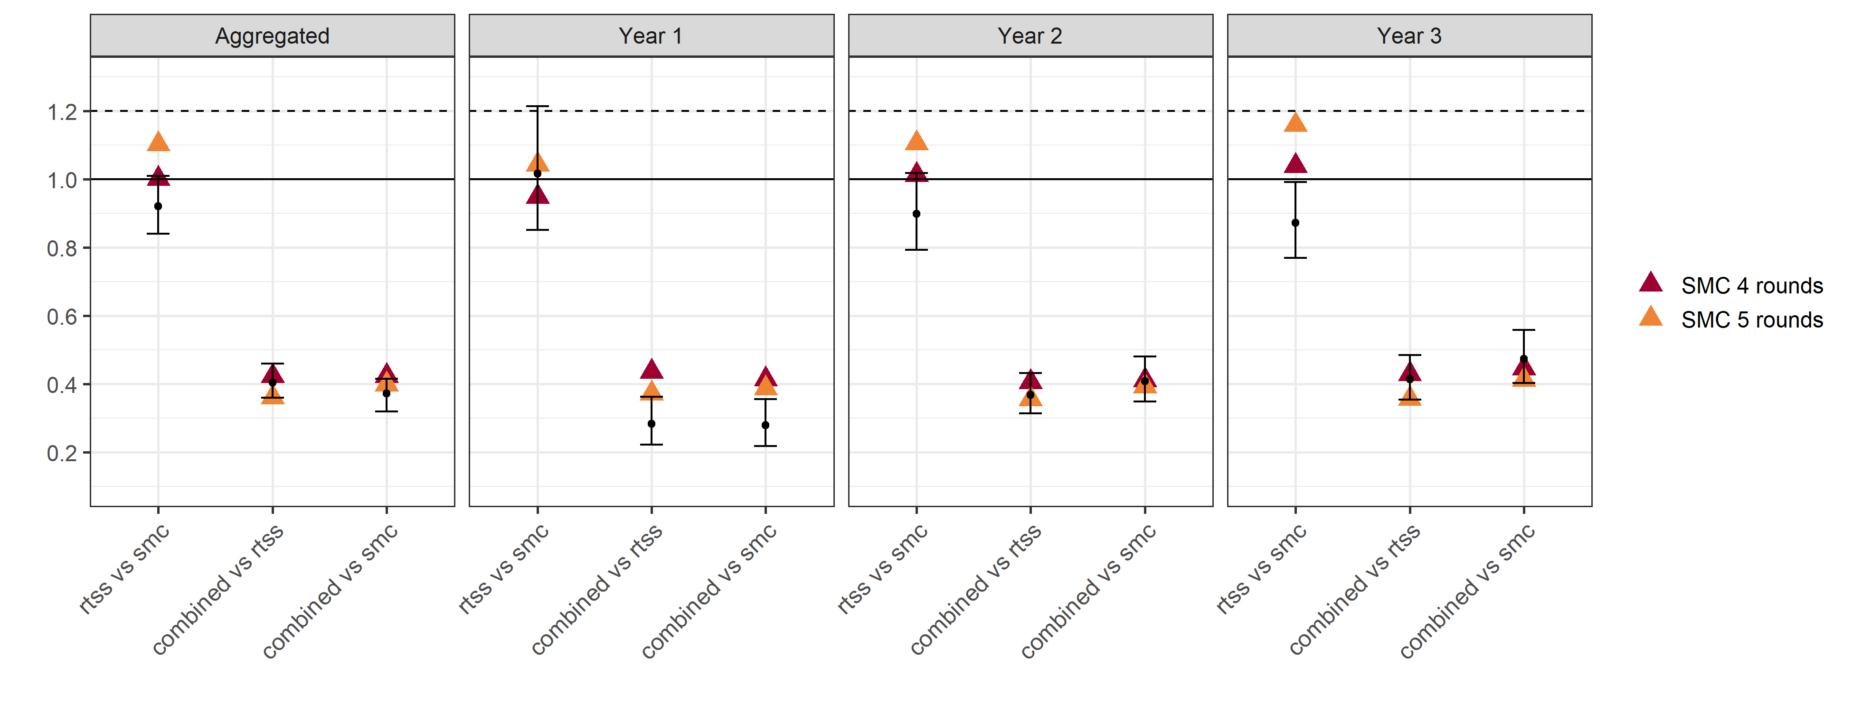

**Figure A3 Sensitivity analysis of trial comparisons when a fifth round of SMC is included.** The datapoints in black are the trial reported pairwise Hazard ratios for the intervention comparisons (Intention-to-treat) listed on the x-axis and the coloured triangles the model predictions. The dashed horizontal line represents the trial specified non-inferiority margin at 1.2 for RTS,S compared to SMC alone and the solid line the equivalence limit at IRR = 1.

**1.2 Caveats for interpretation of the trial results, and extension of SV-SMC trial results to programme settings**

A potential difference between SMC and seasonal vaccination in a programmatic context, but which is not captured by the seasonal malaria vaccination Phase 3b clinical trial, is the incidence prior to the first vaccination contact as a result of the age of eligibility for RTS,S vaccination. Children aged ≥5 and <17 months at enrolment in April 2017 were <5 months of age in April 2016, and thus would not have been eligible for vaccination prior to the 2016 rainy season. However, children in the SMC groups would have been eligible for SMC once at least 3 months of age (Figure A4).

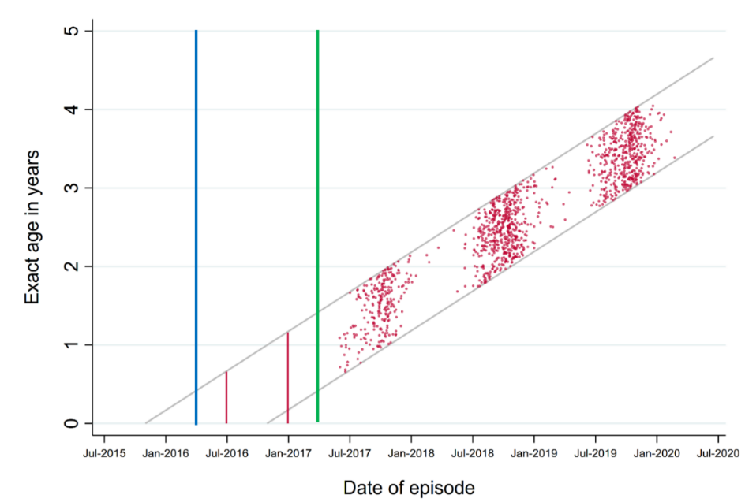

**Figure A4 Timing of episodes of clinical malaria in the RTS,S alone group from the seasonal malaria vaccination Phase 3b clinical trial.** Clinical malaria defined temperature ≥ 37.5°C, or a history of fever within the past 48 hours, and P. falciparum parasitemia ≥ 5,000/mm3. The green line shows the start date of vaccination for children aged between 5-17 months (April 2017). Grey lines the maximum and minimum ages of these children over time. The blue line indicates April 2016 the year before vaccination commenced. Red vertical lines show the approximate timing of the 2016 transmission season. Given the high incidence among vaccinated children in 2017, 2018 and 2019, there would likely have been a high incidence of malaria in 2016 among unvaccinated children, particularly during the peak transmission period which was not captured in this trial.

## Annex 2 – Impact estimates

The model parameterisation and description is consistent with that in the accompanying perennial report: “An update to transmission modelling predictions of the RTS,S/AS01 malaria vaccine’s public health impact and cost-effectiveness to include preliminary evidence on the cost of delivery from the Malaria Vaccine Implementation Programme”.

**Table A1 Parameterisation and set-up of the malaria transmission model.**

|  |  |
| --- | --- |
| **Transmission intensity** | Baseline *PfPR2-10*3%, 5%, 10%, 15%, 20%, 25%, 35%, 45%, 55%, 65% |
| **Seasonality** | “Highly Seasonal” archetype based on seasonality patterns in Fatik, Senegal and “Seasonal” archetype based on seasonality patterns in Upper East, Ghana. |
| **Demographics** | Constant population size and demography based on the life table for Butajira, Ethiopia, with an average life expectancy at birth of 46.6 years. |
| **Case management** | Effective coverage for clinical malaria 45%. |
| **Vaccine scenarios** | 2 main vaccination scenarios are considered, routine age-based immunisation with RTS,S through the EPI, with primary doses given at 6, 7.5 and 9 months of age with a fourth dose at 27 months of age.  Seasonal RTS,S vaccination (SV) primary doses are delivered to all children aged between 5-17 months old in the three months preceding the transmission season with a fourth dose delivered 12 months after the third dose and a fifth dose 24 months after the third dose. A 4-dose SV and 5-dose SV are considered. |
| **Vaccine efficacy and waning** | Model estimates of RTS,S efficacy are based on fitting to Phase III trial data [1]. All vaccination scenarios are run assuming this fitted profile.  In addition, given the results of the model validation several additional changes to the RTS,S efficacy profile are considered for seasonal vaccination to represent uncertainty in the potential vaccine efficacy under this schedule:   1. Improved fourth and fifth dose efficacy to replicate the trial results 2. Improved fourth and fifth dose efficacy and improved efficacy of RTS,S when combined with SMC to replicated potential synergies in the trial results. |
| **Vaccine coverage** | 80% coverage of the first three doses is assumed with a 20% drop off in coverage of the fourth and fifth doses. Total vaccine coverage of 64% presented in the main results. Sensitivity analysis in the range 40–72%. |
| **Other interventions** | Predictions assume that ITN, IRS and access to treatment remain at static levels following vaccine introduction in all scenarios. Seasonal Malaria Chemoprevention with SP+AQ is explicitly modelled when assessing the impact of vaccination and SMC combined. This was modelled as 4 monthly cycles of SMC delivered to children aged 3months-5years old during the peak in transmission season. With a coverage of 75% [2]. For vaccination comparisons alone we assume no SMC delivery in these settings. |
| **Time horizon** | 15 years |

**Outcomes and outcome measures**

The outputs considered in this analysis were clinical malaria cases and deaths from malaria. Events or events averted are presented per 100,000 population or per 100,000 fully vaccinated children. Fully vaccinated children are defined as those receiving the initial primary series. Events averted are presented as the cumulative number of events averted over a 15-year period following the introduction of vaccine dose 3. Unless otherwise stated events averted are calculated relative to a baseline no-vaccination scenario. We report health outcomes for the entire population and disaggregated by 1-year age groupings. Outcome measures are presented as the median values of the model outputs.

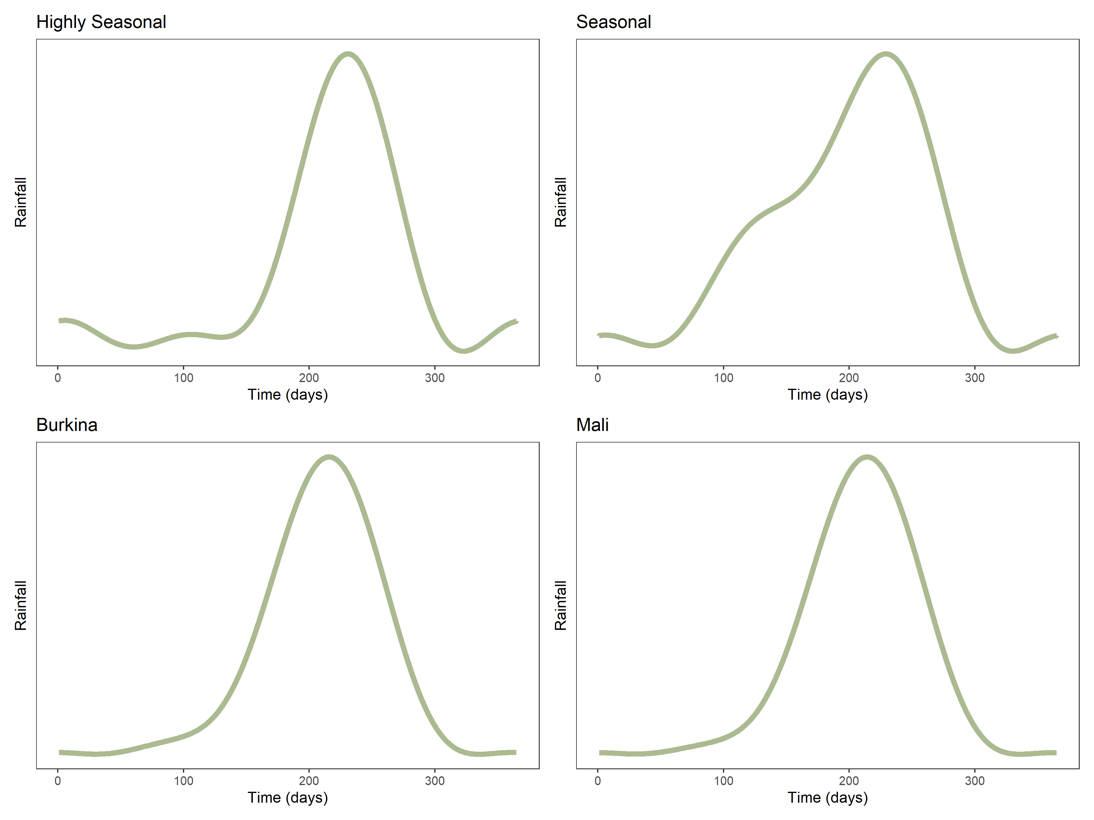

**Figure A5 Rainfall seasonality profiles considered in this modelling analysis.** The top panel depicts the annual average rainfall of the generalised seasonality archetypes chosen for the analysis in Part 2.The Highly seasonal profile is based on rainfall patterns across Fatick, Senegal and the Seasonal profile across Upper East, Ghana. The bottom panel compares these archetypes to the rainfall time-series used for the two trial locations considered for the analysis in Part 1 Haut-Bassins, Burkina Faso and Sikasso, Mali.

**2.1 Simplified modelling of potential vaccination strategies in seasonal settings**

A hybrid vaccination strategy may have the advantage (over seasonal vaccination) of i) preserving a young age at first vaccination, and thus ii) avoiding the situation where children have substantial exposure to malaria before their first dose of vaccine. A hybrid strategy may also have the advantages (over EPI) of i) maximising the efficacy of the fourth and fifth doses (by timing them according to the time of peak risk) and ii) providing scope to give additional doses (which may be easier to do through annual mass campaigns than through the EPI). The safety and efficacy of up to seven RTS,S doses (3-dose primary series, plus four additional annual doses) will be available from the Seasonal malaria vaccination Phase 3b clinical trial in mid-2022.

**Table A2 Key features of EPI, Seasonal and Hybrid vaccination strategies**

|  |  |  |
| --- | --- | --- |
| **Vaccine Strategy** | **Potential Advantage(s)** | **Potential Disadvantage(s)** |
| **EPI vaccination:** age-based priming series,  age-based additional doses. | * Age at first vaccination fixed at 5 or 6 months of age. * Uses existing EPI vaccine infrastructure and current contacts to deliver RTS,S. | * Calendar time of first vaccination varies. In seasonal settings, vaccination may occur several months before period of peak risk, vaccine efficacy may wane in the meantime. * In some areas, EPI coverage is very low. * No obvious EPI contact for doses beyond dose 4. |
| **Seasonal vaccination:** seasonal priming series, seasonal fourth and fifth doses | * Calendar month of first vaccination fixed. * Peak vaccine efficacy of primary series and additional doses are aligned with time of peak risk. * Once the infrastructure for seasonal doses is established, it may be possible to provide more vaccine doses in childhood. * Dose schedule changes could result in heightened efficacy of additional doses compared to EPI scheduling. | * Age at first vaccination varies from 5-17 months. * Some children will be exposed to the peak malaria transmission season prior to their first vaccination. * Effectiveness / cost-effectiveness of additional doses needs further evaluation. |
| **Hybrid vaccination:** age-based priming series, seasonal fourth and fifth doses | * Age at first vaccination fixed at 5 or 6 months of age. * Uses EPI vaccine infrastructure. * Peak efficacy of additional doses are aligned with time of peak risk. * Once the infrastructure for seasonal doses is established, it may be possible to provide more vaccine doses in childhood. | * Calendar time of first vaccination varies, so vaccine efficacy may wane before exposure. * In some areas, EPI coverage is very low. * Effectiveness / cost-effectiveness of additional doses needs further evaluation * A decision will be needed about the minimum spacing between 3rd and 4th dose. |

To investigate the importance of the potential differences between these approaches, a simple model of the effectiveness of different vaccine schedules over the first five years of life was set up. The intention of these models was not to make quantitative predictions of impact, but rather to understand the advantages and disadvantages of the three different potential vaccination approaches in a simple framework.

Figure A6 below shows a schematic representation of vaccination schedules for children born since the initiation of different vaccine programmes. Small black squares show the months at risk for a birth cohort of children born between months 1 and 12, over calendar time, as children age. Yellow, orange and red shading of these boxes indicates the timing of the first, second and third priming dose of RTS,S, respectively. Blue shading indicates the timing of the fourth dose. The months of peak malaria risk (which would dictate the scheduling of seasonal vaccination, and SMC) are shown with dashed red lines.

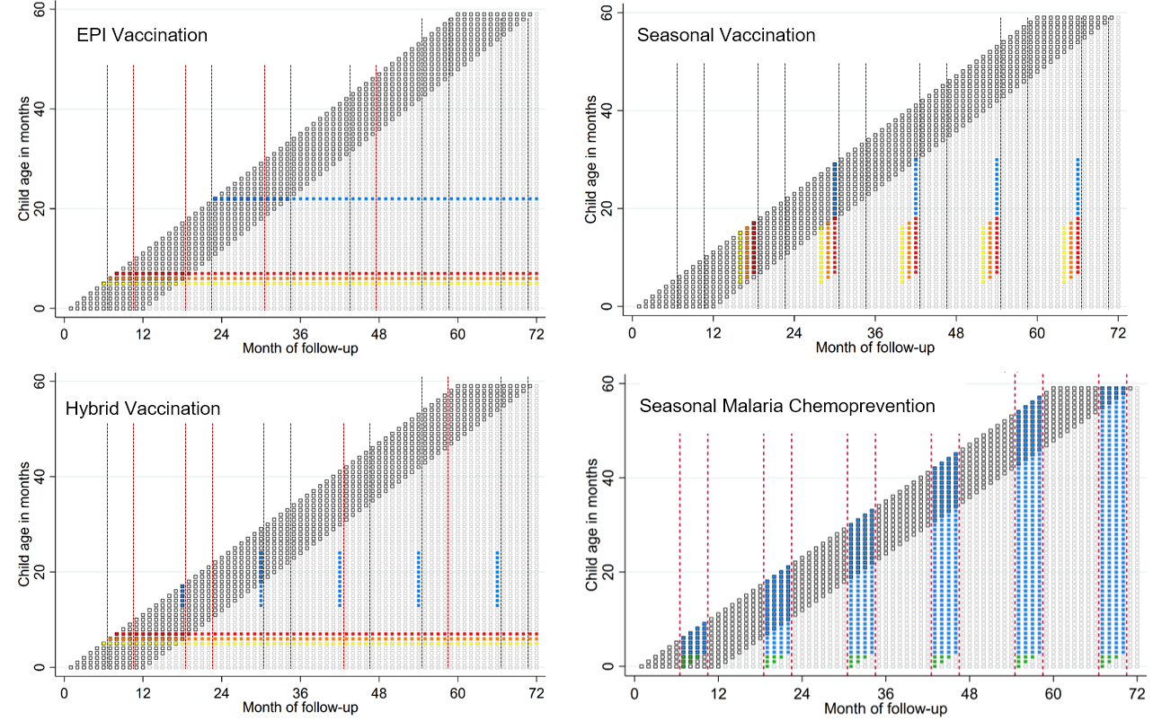

**Figure A6 Schematic showing timing of vaccine doses and SMC by calendar time, and child age, under different strategies.** The cohort of children born in the first year after implementation of the different strategies is shown in bold. Yellow, orange and red shading of these boxes indicates the timing of the first, second and third priming dose of RTS,S, respectively. Blue shading indicates the timing of the fourth dose or SMC delivery. Green cells indicate children who would be aged <3 months at the beginning of the transmission season, but who would become old enough to receive SMC later in the SMC period. The months of peak malaria risk (which would dictate the scheduling of seasonal vaccination, and SMC) are shown with dashed red lines.

Vaccination schedules shown are:

* EPI, with age-based timing as in Malawi, with the primary series given at 5, 6 and 7 months of age, and fourth dose at 22 months.
* Seasonal vaccination, with the first dose of the 3-dose primary series given to children at least 5 months of age, 3 months prior to the transmission peak, with the fourth dose given 1 month before the transmission peak, in the subsequent year.
* Hybrid vaccination, with the primary series given at 5, 6 and 7 months of age, and seasonal doses given 1 month before the transmission peak. For illustration here, it is assumed that the minimum time between dose 3 and dose 4 would be at least 6 months, but this condition could be varied and will need further research to determine optimal timing.

An example SMC schedule, targeting the peak 4 months is also shown. Blue cells indicate the months in which SMC would be administered.

Incidence was estimated for each month of age from 0-59 months, for children in the birth cohort born between January and December of the first year of implementation. The incidence can be varied by calendar month, to capture the impact of different seasonality patterns on the performance of the different intervention schedules. The efficacy of RTS,S was assumed to decay as a simple step function, as reported in the WHO position paper based on the Phase III data [3]. The efficacy of SMC was assumed to be 80% in the month of administration, and 0 otherwise.

Figure A7 shows the range of seasonality patterns included in the schedule models, based on routine HMIS data from different sub-prefectures of Guinea in 2018. Data on confirmed cases of malaria in individuals above the age of five years were used, to avoid any influence of SMC (which is deployed in some sub-prefectures of Guinea) on the seasonality patterns.

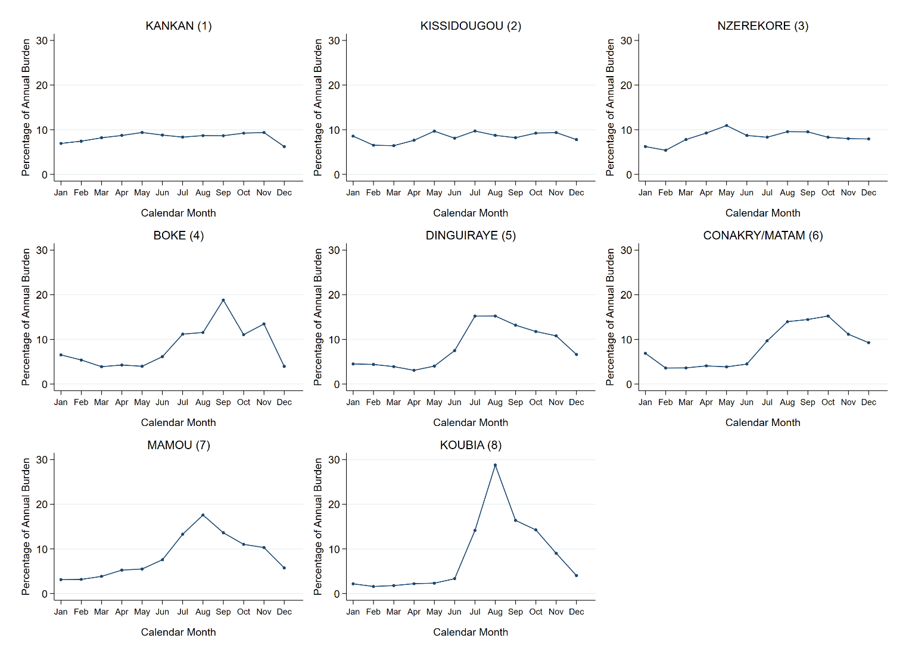

**Figure A7 Seasonality patterns used in the schedule modelling, based on data collected by the Guinea PNLP.** Percentage of the annual burden in 2018 is shown, by calendar month.

Figure A8 shows the cumulative incidence by month for the cohort of children born between month 1 and month 12 after different vaccination programmes are introduced. Scenario 6 (Conakry/Matam) is used for illustration. The top three panels show results for vaccination strategies without SMC, and the bottom three panels for vaccination strategies in combination with SMC. The cumulative incidence in scenarios with no intervention and with SMC alone are shown in all panels, for reference.

When single intervention strategies were considered, with a maximum of four doses of vaccine, the cumulative incidence was lowest in the SMC alone (reflecting the sustained high efficacy of SMC up to five years of age). The difference in cumulative incidence between the three vaccination strategies at five years of age was not large, but slightly favoured SV. The advantage of Seasonal Vaccination increases in more seasonal scenarios and decreases in less seasonal scenarios (results not shown).

However, an important point is the relative performance of Seasonal Vaccination compared to EPI or Hybrid vaccination in the first 24 months (Figure A8B). Due to the delay in first vaccination for SV (explained in more detail in Figure A9), there is no benefit of SV until month 19: the SV alone line (blue dash) is the same as the no intervention line (solid grey) until this point. Conversely, the benefit of EPI vaccination and Hybrid vaccination is apparent from month 9 onwards, as children who have received vaccines at the age of 5, 6 and 7 months begin to benefit from vaccine protection. The potential for EPI or Hybrid strategies to have superior efficacy at young ages, due to younger age at first vaccination, could translate into differences in severe malaria cases and deaths and should be considered carefully as a potential advantage of these strategies over SV strategies.

**Figure A8 Cumulative incidence over the first five years of life under different vaccination schedules.** Top Panels show cumulative incidence for single intervention strategies, expressed as a percentage of the cumulative incidence at 5 years in a scenario with no intervention. Panel A shows cumulative incidence up to 60 months for the birth cohort between month 1 and 12, for scenarios with no intervention, SMC alone, and vaccination strategies with up to 4 doses of RTS,S. Panel B shows an enlarged version of the hatched area in Panel A. Panel C shows the same as Panel A, but allowing up to 7 doses of RTS,S in vaccination strategies. Panel D shows cumulative incidence for no intervention, SMC alone, and vaccination strategies with up to 4 doses of RTS,S in combination with SMC. Panel E shows an enlarged version of the hatched area in panel D. Panel F shows the same as Panel D, i.e. vaccination in combination with SMC, but with up to 7 doses of RTS,S.

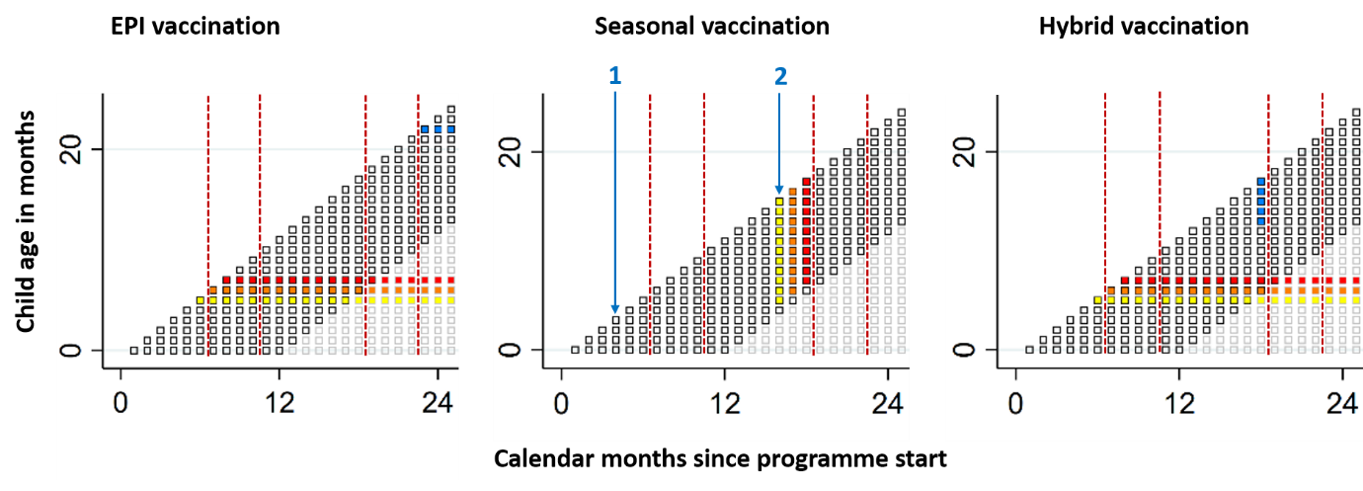

**Figure A9 Dosing patterns in the first 24 months, among the birth cohort and differences between SV and EPI/Hybrid vaccination.** The EPI and Hybrid strategies use EPI vaccination contacts for the primary series, so ensures the first dose of vaccine is given at five months of age (with the schedule used in the MVIP study in Malawi) or at 6 months of age (using the schedule used in Ghana and Kenya, not shown here). With SV, in month 4 (blue arrow, marked 1), when the three-monthly doses of the primary series would begin prior to the first rainy season, no children born since the programme began would have reached the age of five months, so no children from the birth cohort would be eligible for vaccination at that time. At the corresponding time the following year, month 16, (blue arrow, marked 2), most children from the birth cohort would have reached the age of 5 months and be eligible for vaccination. Children from the birth cohort born in December (month 12) would have reached only 4 months of age by the time of the pre-season vaccination (in month 16), so would not be eligible for first vaccination until the subsequent season (this would occur in month 28, not shown here).

Disaggregating impacts by age in the population model of EPI and SV to investigate this further we observed some disparities between EPI and SV. EPI had a greater impact in terms of reducing clinical cases and deaths in the first two years of life (children aged <24 months) compared to SV where impact was greater and sustained from age 2 onwards (Figure A10). This disparity resulted in a slightly higher number of deaths between approximately 10-20 months of age (reflecting the age range when all children would have received three doses under EPI, but not all children would have received three doses under SV). This is most marked when SV was compared to EPI in seasonal settings. In highly seasonal settings, the disadvantage of SV (due to higher age at vaccination) was offset somewhat by the higher effectiveness of SV (due to the shorter transmission season) (Figure A11).

We predict a shift in cases to older ages due to reduced malaria exposure leading to delays in the development of natural immunity (Figure A10, Figure A12). This effect is delayed with the introduction of a fifth dose in the SV schedule and is of similar magnitude across all vaccination scenarios and seasonality profiles. Despite this the overall cumulative impact of all schedules and intervention models remains positive over this 15-year horizon in all settings.

**Figure A10** Cumulative number of clinical cases (top row) and deaths (bottom row) averted over 15 years for individuals up to 20 years old in 1-year age bands.The total cases averted are shown per 100,000 population for both seasonality settings. Results are presented for 4 transmission intensity levels.

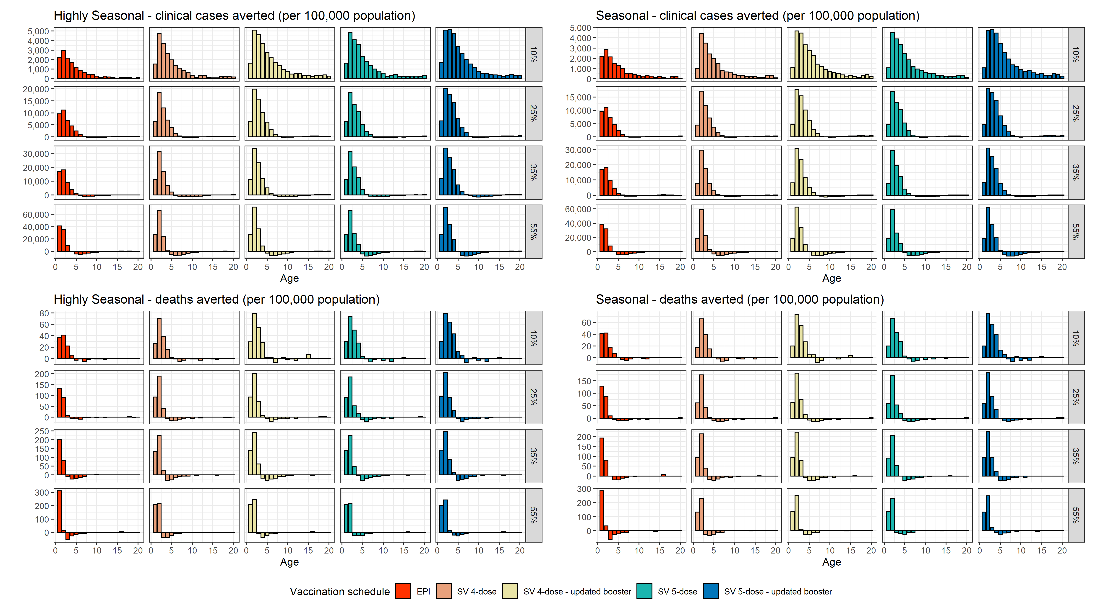

**Figure A11** Deaths averted in a single one-year cohort of children. Columns represent four of of representative baseline *PfPR2-10* levels. All SV scenarios are represented by the blue line as impact is consistent following the primary series. Results are presented for a Seasonal setting (top row) and a Highly Seasonal setting (bottom row).

**Figure A12** Cumulative number of clinical cases (top row) and deaths (bottom row) averted over 15 years for individuals up to 20 years old in 1-year age bands.The total cases averted are shown per 100,000 population for both seasonality settings. Results are presented for 4 transmission intensity levels.

**Sensitivity analysis to vaccine coverage**

Outputs per 100,000 fully vaccinated children remain consistent across the range of coverages (50%–90%) (Figure A13) as vaccine impact scales approximately linearly with vaccine coverage (Figure A13).

**Figure A13 Impact of primary dose vaccine coverage on health outcomes.** Outcomes are cumulative over 15 years and averaged over all baseline *PfPR*2-10 (3%-65%). Coverage of the additional fourth and fifth doses was set to 80% of the primary series.

## Annex 3 – Cost effectiveness

When considering vaccine introduction alone in seasonal settings, estimates of the incremental cost per clinical case or DALY averted were made in comparison to baseline no vaccination scenarios with standard levels of access to treatment and existing vector control. The vaccine alone scenario assumes no access to SMC. When considered in combination with SMC, cost-effectiveness estimates were made in comparison to baseline SMC delivery at 75% coverage and standard levels of access to treatment and existing vector control, so results are incremental to SMC. SMC cost estimates were informed by Gilmartin et al [4](Table A3). Data used for the cost-effectiveness analysis are presented in the tables below. Costs were aligned with the perennial estimates report (“An update to transmission modelling predictions of the RTS,S/AS01 malaria vaccine’s public health impact and cost-effectiveness to include preliminary evidence on the cost of delivery from the Malaria Vaccine Implementation Programme”).

**Table A3 Costing data considered in this analysis. All data presented US$.**

|  |  |  |  |  |  |  |  |
| --- | --- | --- | --- | --- | --- | --- | --- |
| Cost per vaccine dose | Cost per vaccination including vaccine cost* | Cost of delivery per dose (economic, recurring)± | | | Total cost per dose | | |
| Mean | Min | Max | Mean | Min | Max |
| $2 | $2.69 | $1.62 | $0.96 | $2.67 | $4.31 | $3.65 | $5.36 |
| $5 | $6.52 | $1.62 | $0.96 | $2.67 | $8.14 | $7.48 | $9.19 |
| $10 | $12.91 | $1.62 | $0.96 | $2.67 | $14.53 | $13.87 | $15.58 |

* Includes vaccines, injection and reconstitution syringes, safety boxes, freight, insurance and wastage as per Penny et al [5].

± The recurring cost of delivery excludes the initial set-up costs related to RTS,S introduction and delivery and may be more representative of the program costs in the long run. Reflect interim data from three MVIP countries averaged. The mean, min and max delivery cost values represent average, minimum and maximum values, respectively, across the three MVIP countries.

**Table A4 Non-vaccine related costs**

|  |  |  |
| --- | --- | --- |
| Intervention | Unit cost | Description |
| SMC with SP+AQ | $1.07 per child per monthly course [4] | Weighted average recurrent economic cost of administering four monthly SMC cycles during the ACCESS SMC program. Averaged over different delivery approaches, inflated to $US 2021. |
| Clinical malaria case management | $1.47 [5] | Costs are estimated by severity of illness and cover first-line antimalarial drugs, diagnostics, and related supplies including freight and wastage. We assumed full compliance and adherence with the age dosage. |
| Severe malaria case management | $22.41 [5] |

Figure A14A presents the incremental cost-per-case and cost-per-DALY averted for each vaccination schedule compared with no vaccination and standard levels of access to treatment for an assumed cost per dose of $5 over a range of baseline *PfPR2-10*. Figure 14A assumes no access to SMC. Figure A14B presents the incremental cost-per-case and cost per-DALY averted for each vaccination schedule in combination with SMC compared to SMC and standard levels of access to treatment. Figure 15 presents these same estimates for an assumed cost per dose of $2, $5 and $10.

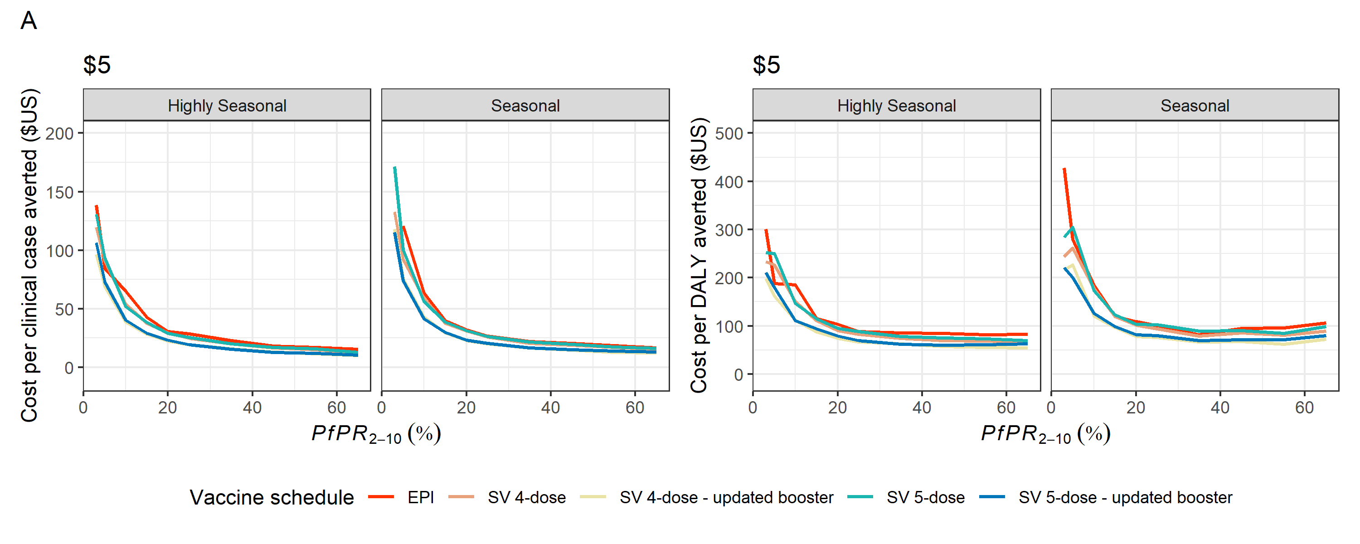

**Figure A14** Summary of cost-effectiveness estimates for different RTS,S vaccination schedules A) when delivered alone ICERs relative to no-vaccination and B) when delivered with SMC ICERs relative to SMC. Cost-per-case and cost-per-DALY averted as a function of baseline PfPR2-10 for a vaccine cost of $5. Lines represent model median estimates assuming a mean delivery cost of $1.62. SMC cost per child per monthly course of $1.01.

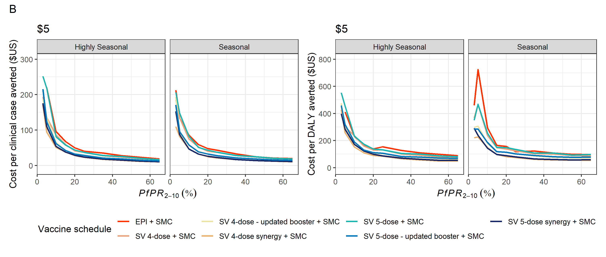

**Figure A15** Summary of cost-effectiveness estimates for different RTS,S vaccination schedules A) when delivered alone ICERs relative to no-vaccination and B) when delivered with SMC (bottom two rows) ICERs relative to SMC. as a function of baseline PfPR2-10 for different vaccine costs of $2, $5, and $10. Lines represent model median estimates assuming a mean delivery cost of $1.62. SMC cost per child per monthly course of $1.01

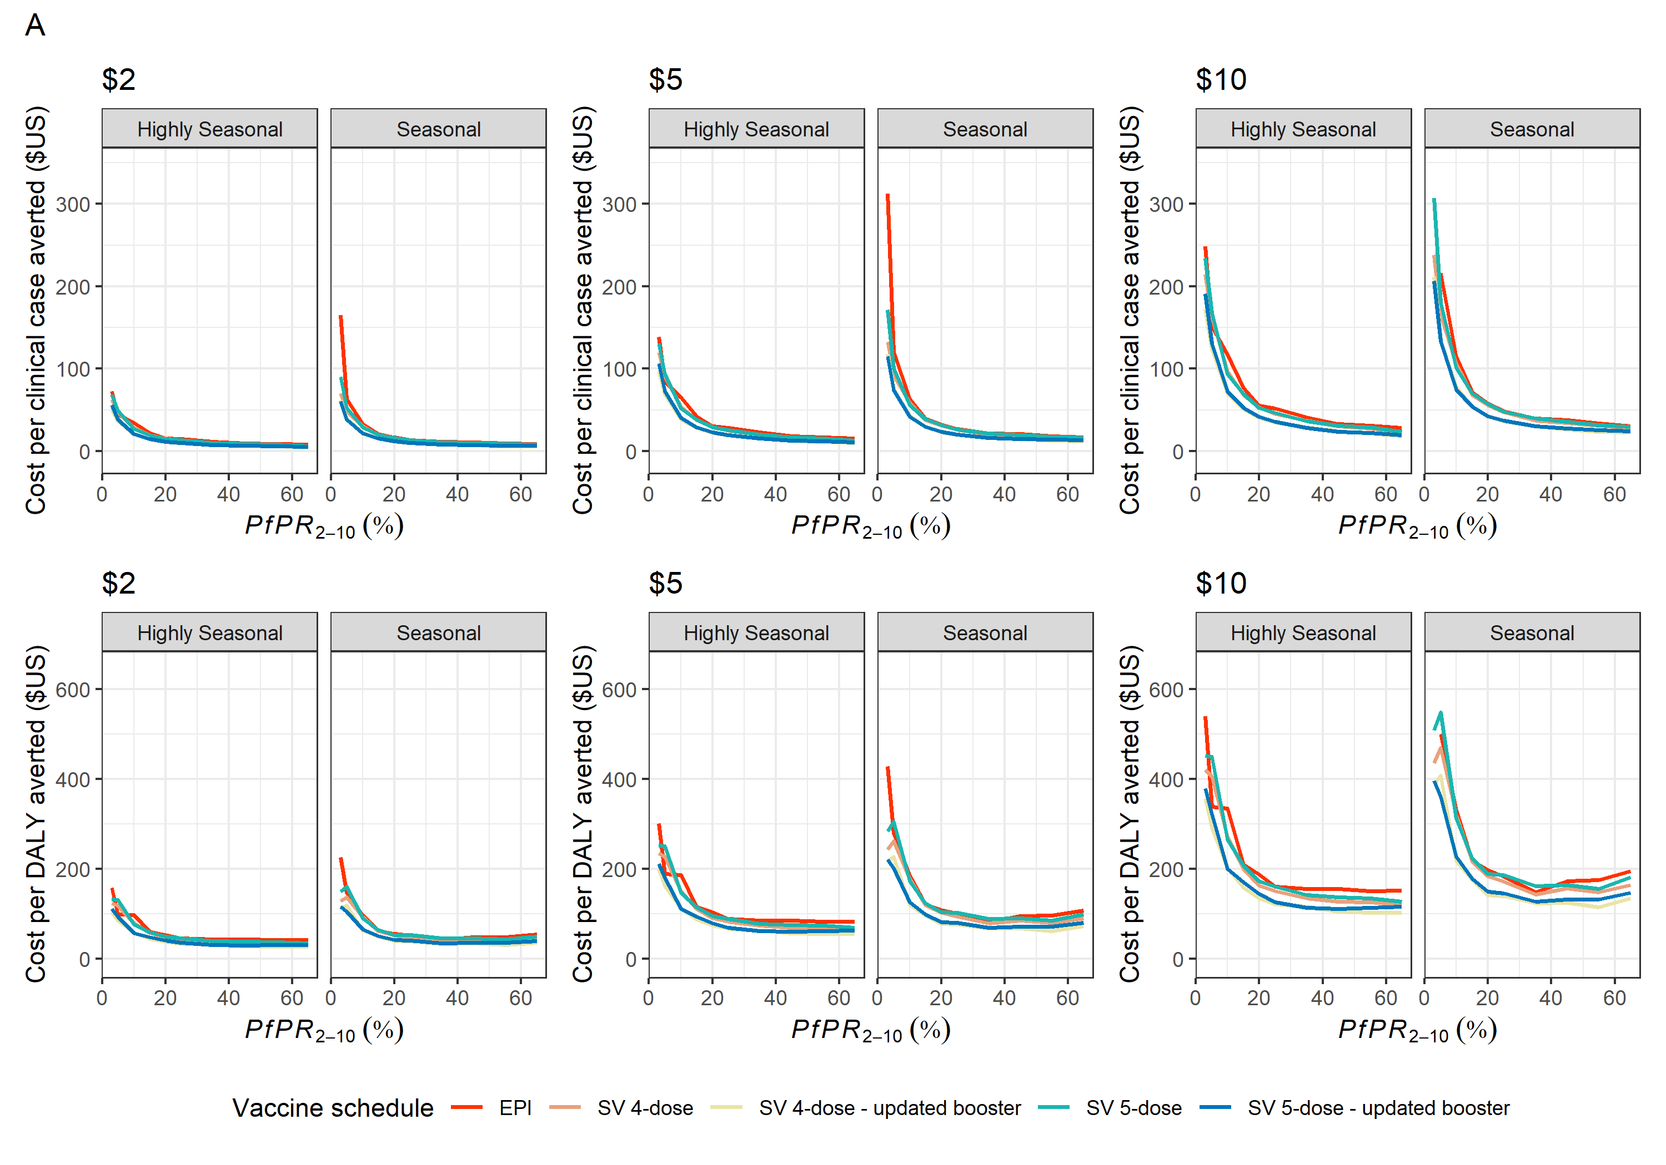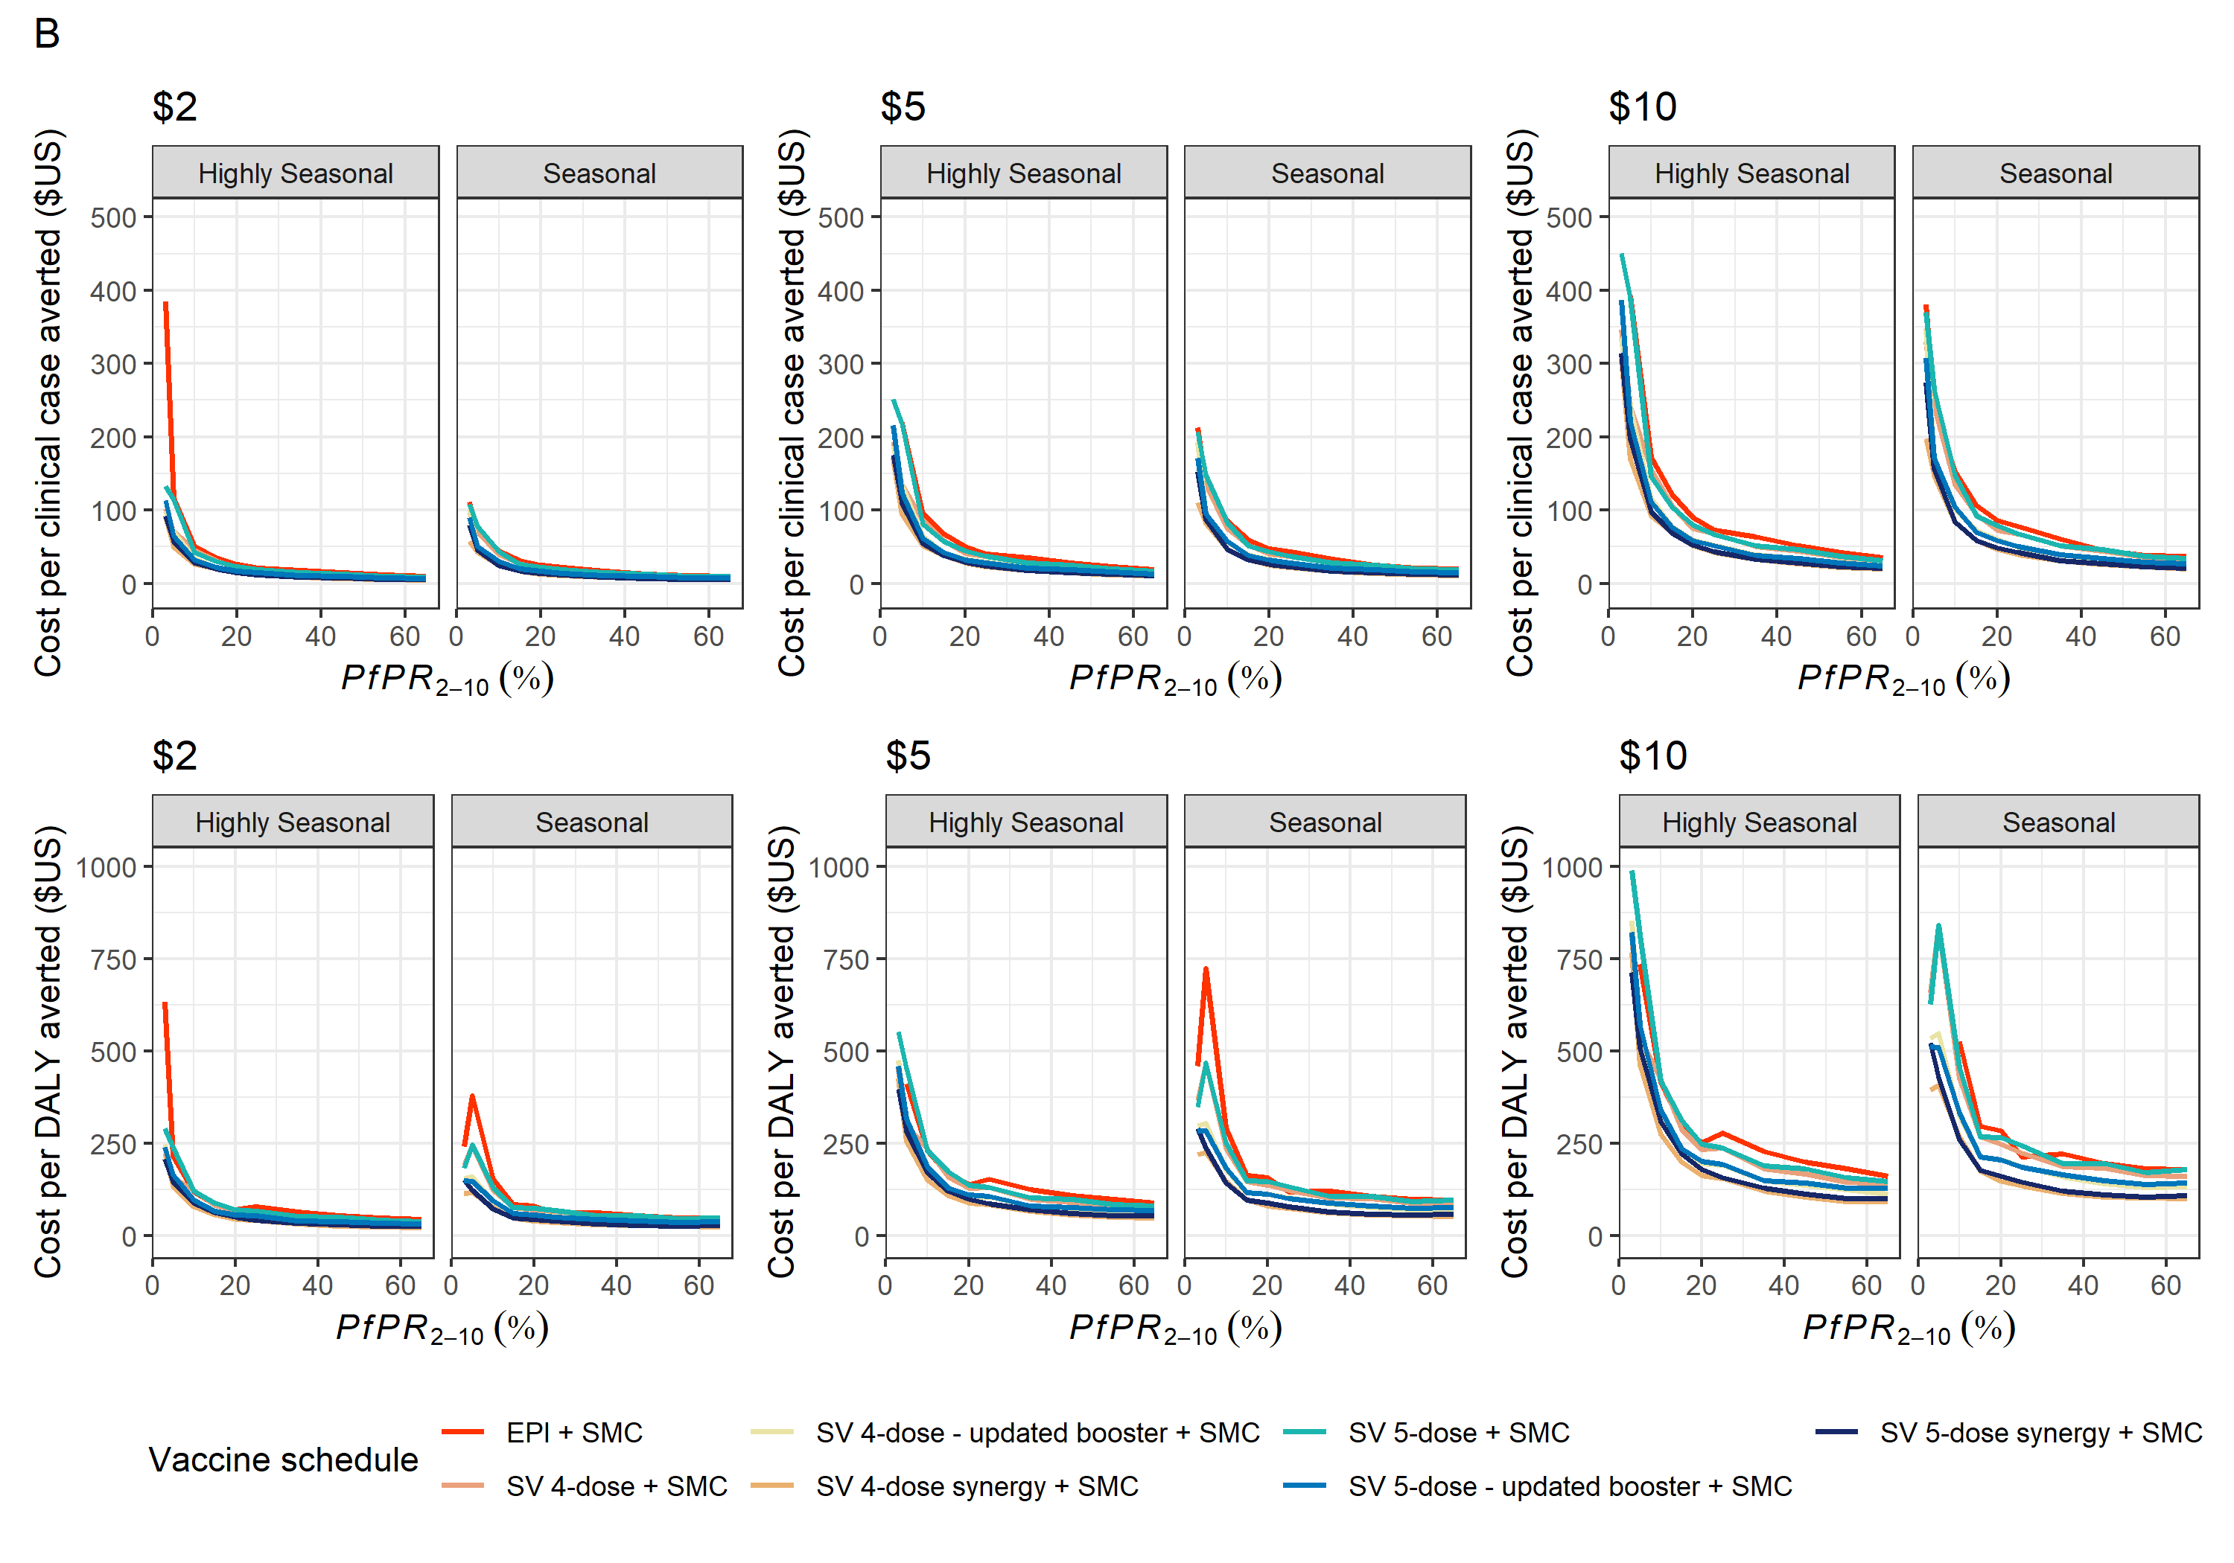

**Figure A15** Summary of cost-effectiveness estimates for different RTS,S vaccination schedules A) when delivered alone ICERs relative to no-vaccination and B) when delivered with SMC (bottom two rows) ICERs relative to SMC. as a function of baseline PfPR2-10 for different vaccine costs of $2, $5, and $10. Lines represent model median estimates assuming a mean delivery cost of $1.62. SMC cost per child per monthly course of $1.01



**Sensitivity of cost-effectiveness estimates to cost of delivery inputs**

**Table A5** Comparison of cost-effectiveness estimates across cost-of-delivery ranges for different vaccination schedules without SMC delivery after 15 years in regions with a *PfPR2-10* between 10-50%. Results are averaged across both seasonality profiles. ICERs are calculated relative to no-vaccination and standard levels of access to treatment and existing vector control.

|  |  |  |  |  |  |  |
| --- | --- | --- | --- | --- | --- | --- |
|  | Interventions | | | | | |
|  | EPI | | | SV (averaged over all models) | | |
|  | Min cost of delivery $0.96 | Mean cost of delivery $1.62 | Max cost of delivery $2.67 | Min cost of delivery $0.96 | Mean cost of delivery $1.62 | Max cost of delivery $2.67 |
| ICER per DALY averted | | | | | | |
| $2 per dose | $48.59 | $58.04 | $73.06 | $39.77 | $47.63 | $60.14 |
| $5 per dose | $103.39 | $112.84 | $127.87 | $85.39 | $93.25 | $105.76 |
| $10 per dose | $194.83 | $204.28 | $219.31 | $161.50 | $169.36 | $181.87 |
| ICER per clinical case averted | | | | | | |
| $2 | $14.80 | $17.66 | $22.22 | $11.73 | $14.04 | $17.71 |
| $5 | $31.43 | $34.29 | $38.85 | $25.14 | $27.44 | $31.11 |
| $10 | $59.17 | $62.03 | $66.59 | $47.50 | $49.80 | $53.48 |

**Table A6** Comparison of cost-effectiveness estimates across cost-of-delivery ranges for different vaccination schedules combined with SMC delivery after 15 years in regions with a *PfPR2-10* between 10-50%. Results are averaged across both seasonality profiles. ICERs are calculated relative to SMC with standard levels of access to treatment and existing vector control.

|  |  |  |  |  |  |  |
| --- | --- | --- | --- | --- | --- | --- |
|  | Interventions | | | | | |
|  | EPI + SMC | | | SV (averaged over all models) + SMC | | |
|  | Min cost of delivery $0.96 | Mean cost of delivery $1.62 | Max cost of delivery $2.67 | Min cost of delivery $0.96 | Mean cost of delivery $1.62 | Max cost of delivery $2.67 |
| ICER per DALY averted | | | | | | |
| $2 per dose | $68.43 | $81.58 | $102.40 | $50.23 | $60.09 | $75.80 |
| $5 per dose | $144.52 | $157.63 | $178.50 | $107.52 | $117.39 | $133.10 |
| $10 per dose | $271.48 | $284.59 | $305.46 | $203.11 | $212.98 | $228.69 |
| ICER per clinical case averted | | | | | | |
| $2 | $22.06 | $26.30 | $33.02 | $15.14 | $18.18 | $22.82 |
| $5 | $46.58 | $50.80 | $57.51 | $32.34 | $35.31 | $40.03 |
| $10 | $87.45 | $91.67 | $98.39 | $61.05 | $64.01 | $68.73 |

**Acknowledgements**

The authors thank Professor Brian Greenwood and Dr Daniel Chandramohan of the London School of Hygiene and Tropical Medicine, Dr Jean-Bosco Ouedraogo of the Institut de Recherche en Sciences de la Sante, Burkina Faso and Dr Alassane Dicko of The Malaria Research and Training Center, University of Science, Technology and Techniques of Bamako, Mali for sharing the seasonal malaria vaccination Phase 3b clinical trial clinical trial results for the model validation process and for their helpful discussions surrounding this process. We also would like to thank Professor Paul Milligan of the London School for Hygiene and Tropical Medicine, Dr Eugene Kaman Lama, Coordinator of the National Malaria Control Programme in Guinea, Dr Kovana Marcel Loua of the Universite Abdel Gamal Nasser, Conakry, Guinea for providing data on the seasonality patterns of Malaria in Guinea used for the simplified modelling work in Annex 2.1.

**References**

1. White MT, Verity R, Griffin JT, et al. Immunogenicity of the RTS,S/AS01 malaria vaccine and implications for duration of vaccine efficacy: Secondary analysis of data from a phase 3 randomised controlled trial. Lancet Infect Dis **2015**; 15:1450–1458. Available at: http://dx.doi.org/10.1016/. Accessed 26 May 2021.

2. Baba E, Hamade P, Kivumbi H, et al. Effectiveness of seasonal malaria chemoprevention at scale in west and central Africa: an observational study. Lancet **2020**; 396:1829–1840.

3. World Health Organization. Weekly epidemiological record Relevé épidémiologique hebdomadaire. Available at: http://www.who. Accessed 15 August 2021.

4. Gilmartin C, Nonvignon J, Cairns M, et al. Seasonal malaria chemoprevention in the Sahel subregion of Africa: a cost-effectiveness and cost-savings analysis. **2021**; :199. Available at: www.thelancet.com/lancetgh. Accessed 15 August 2021.

5. Penny MA, Verity R, Bever CA, et al. Public health impact and cost-eff ectiveness of the RTS,S/AS01 malaria vaccine: a systematic comparison of predictions from four mathematical models. www.thelancet.com **2016**; 387:367. Available at: http://dx.doi.org/10.1016/. Accessed 15 August 2021.